

Group Assignment

Level: 05

Professional Practice & Project Management

Batch Code: COM2521

Dew Ranith – CB016891

Wokwi link - https://wokwi.com/projects/475411875379442689
Github link - https://github.com/DewRanith/hardware-micro-controllers-and-sensors-scenario-2

Table of Contents
Scenario and scope 3
Scenario and problem statement 3
Prototype scope 3
MoSCoW prioritisations 3
Major design decisions 4
System Design 5
Operational modes and transitions 5
Priority logic hierarchy (design challenge) 6
Firmware architecture 8
Feature implementation 8
Digital I/O and register-level GPIO 8
Timers and interrupts 9
ADC: analogue input 10
PWM servo control 10
Modes of operation 10
Scheduled and timed behaviour 10
Serial communication (UART) 11
I2C OLED display 11
Sensor validation and safety logic 11
User Manual 12
Components 12
Wiring 12
Software set-up 14
Operating each mode 14
Autonomous 14
Manual Override (maintenance / sanitation) 14
Safety (sensor fault) 15
Configuration (engineers) 15
Commercial IoT Appraisal 16
Testing 18
Conclusion 23
Reference 23

Scenario and scope

Scenario and problem statement
This is a report for an esp32 based IOT device for scenario 2. The Automated Commercial Micro-Climate Nursery. High value crops that want indoor nurseries are damaged by two fast acting threats midday heat, which stall growth within minutes, and stagnant, humid air pockets, which can cause disease. A third threat appears with the solution opening of a vent, admit air dangerously cold. The controller must coordinate temperature and natural light, drive the vent and supplemental grow light, give staff an override for maintenance and fail safely when a sensor cannot be trusted.
Besides the mandated hardware on an ESP32 project, the prototype consists with some add parts and outdoor DHT22 Sensor, a potentiometer for manual control of servo, and four buttons, led for indicator purpose and lighting purpose and a buzzer for operators.

Prototype scope
What prototype does | What prototype does not
Read indoor temperature/humidity and validate every reading. | closing the vent is its only defense against cold
Measure outdoor temperature to decide that opening the vent is safe | Measuring wind, rain, CO₂ or soil moisture
Set 3 vent servos to a calculated angle 0 - 90, that  moved smoothly | Drive real vent motors, relays or 24 V actuators
Switch two grow LEDs in stages from the filtered LDR level | Control light intensity (PWM dimming) or photoperiod schedules
Provide autonomous mode, manual override mode and safety mode with defined transitions | Offer remote (Wi-Fi/cloud/app) monitoring or alerts
Enter a fixed safe posture on a sensor fault and name the failed sensor | Store settings or logs in non-volatile memory (settings reset on reboot)
Accept threshold configuration over UART and stream live status | Authenticate operators or restrict who can change settings

MoSCoW prioritisations
Priority | Requirement | Status
Must | Read and validate the indoor DHT22 and detect NaN or out-of-range data | Done
Must | LDR switches supplemental grow LEDs when natural light is low | Done
Must | Vent opens when indoor temperature exceeds a threshold, at a calculated angle | Done
Must | Three modes (Autonomous, Manual, Safety) with defined transition triggers | Done
Must | Manual bypasses all automation and locks vents open. OLED clearly shows the mode | Done
Must | Predefined safe posture - OLED names the failed sensor and prompts the operator | Done
Must | OLED shows temperature, humidity, light and vent status always | Done
Must | Priority logic resolving competing conditions | Done
Must | Non-blocking timing via hardware timer or interrupts. UART status and configuration | Done
Should | Outdoor DHT22 so the cold outside conflict can be detected | Done
Should | Hysteresis on every threshold fault confirmation over two reads | Done
Should | Latched fault that only clears when a fresh reading is valid | Done
Should | Scheduled air exchange purge against stagnant air audible alarm | Done
Should | Thresholds configurable at run time over UART, with range checking | Done
Could | Staged grow lighting. One or two lamps by darkness | Done
Could | Potentiometer for any vent angle during manual work; smooth servo slew | Done
Could | Graceful degradation if the outdoor sensor fails; LDR stuck-rail fault detection | Done
Could | Store configuration in flash so it survives power loss | Not done
Won’t | Wi-Fi, MQTT, cloud dashboard or phone alerts | Exclude
Won’t | Heating, CO₂ dosing, irrigation, wind/rain sensing | Exclude
Won’t | Operator authentication and data logging | Exclude

Major design decisions
An outdoor DHT22 was added - The design challenge is if it is dangerously cold outside but the inside needs to open the vents. This situation cannot be solved only by measuring the indoor temperature and needed to measure the outdoor temperature. The second DHT22 sensor reuses the same driver and validates the code at the cost of one of the GPIO pins. If it fails, the system will assume the worst case and keep running graceful degradation rather than a nuisance shutdown.
3 vents move together – A commercial bay has vent windows along its ridge. Each servo motor has its own LEDC PWM channel but commanded to one calculated angle, represent one vent group and show multi-channel PWM. All 3 servo motor move one degree per 20ms, which can avoid mechanical shocks and the surge of 3 servos jumping at once.
The safe posture is vent 30 degrees is grow LEDs off not vent closed. When temperature is unknown, closing fully risks cooking the crop during exactly the midday spike as the scenario describes, and opening fully will risk chilling it. A partly open vent keeps air moving, which also addresses the stagnant air, with limited thermal exposure. Grow LEDs are switched off because they are a heat source.
All operator actions are on buttons – UART is only for configuration. Floor staff doesn’t use laptops so mode, reset, light and vent are physical buttons handled by interrupts. The serial terminal accepts set <name> <value> commands for commissioning engineers and stream status, which satisfies the UART requirements without making a daily operation depend on a pc.
One hardware timer is the time base – A 1ms timer interrupt increments the program clock and also generate a tone using buzzer. So, no delay() or tone() call is needed when the operation is running. Every periodic job is scheduled from this clock.

System Design

Operational modes and transitions
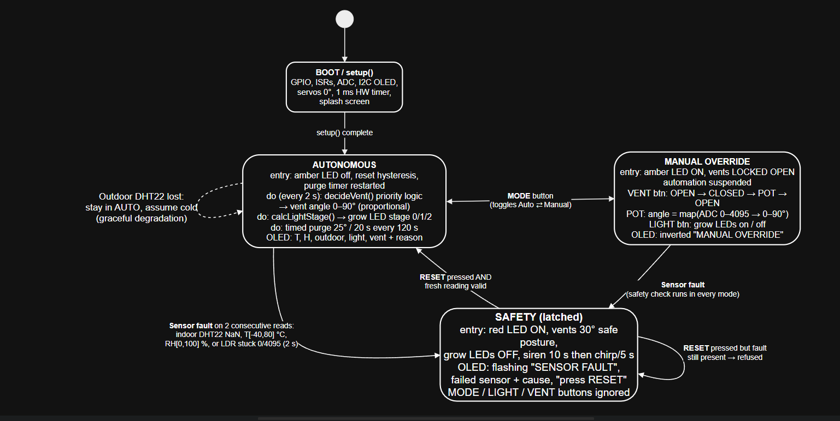
This is a diagram of the implemented firmware. Every operation is caused by a defined input condition and runs through a single function called “changedMode()” which applies an action of the newly begun state. This means an operation or a mode cannot be entered without an output being set correctly.
Form | To | Tigger condition | Guard/notes
Power on | Autonomous | Setup() completes | Vents start closed(0º)
Autonomous | Manual | Mode button | Vents lock open immediately
Manual | Autonomous | Mode button | Hysteresis memory and purge timer reset
Autonomous or Manual | Safety | DHT22 OR LDR sensor not giving signal | Must persist for 2 consecutive 2s read
Safety | Autonomous | Reset button | Only if a fresh reading is valid otherwise refused
Safety | Safety | Mode, vent , light button | Safety cannot be bypass
Autonomous | Autonomous | Outdoor dht22 failed | Outdoor assumed called and warning on OLED

Priority logic hierarchy (design challenge)
Competing conditions are resolved by a strict 8 level hierarchy. 2 level safety and manual the automatic logic is not executed. Within autonomous decideVent() treats levels 5-7 are requesting for a vent angle, when taking about the largest and levels 3-4 as limits applied afterwards. Requests cannot be overriding a protective limit, however many of them are active.
Level | Condition | Action | Justification
L1 Safety | Sensor fault confirmed | Vent 30º, LEDs off, alarm | Any automatic data cannot be trusted without valid data
L2 Manual | Operator override | Operator decides | A person on site knows about maintenance the sensors cannot see
L3 Too cold | Indoor ≤ 18 °C | Vent closed, overrides all below | Cold shock damage is immediate; humidity damage is slow
L4 Cold limit | Outdoor ≤ 10 °C or outdoor sensor failed | cap = 15° + s²·75° | Admits cold air only in proportion to the heat danger
L5 Heat | Indoor ≥ 30 °C (off ≤ 29 °C) and outside cooler | 20° + s·70° (proportional) | Opening grows with severity; skipped if outside is hotter
L6 Humidity | RH ≥ 85 % (off ≤ 75 %) | At least 35° | Breaks up humid, stagnant air
L7 Purge | Timer window active | At least 25° for 20 s | Scheduled air exchange
L8 Default | None of the above | Closed | Retains warmth

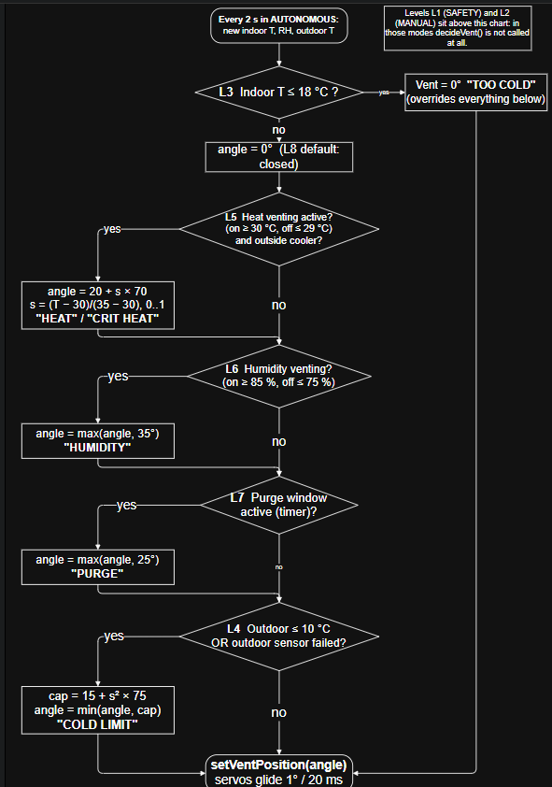

The key algorithmic is how the cold limit interacts with the heat. Both are functions of single severity value, s= (T - 30)/ (35 - 30), CLAMPED TO 0-1. Heat asks for 20 degrees + 70s, but when outdoor air is cold the opening will be capped about 15 degrees + 75s^{2.} because the cap grows with the square of severity, it stays small while in the heat is mild. In the range of a draught of cold air is the greater risk. The cap then rises to the critical 35ºC, where the major problem becomes the heat. St s = 1 cap reaches 90º and in this case heat wins outright.

Firmware architecture
Diagram shows how the work is divided. Interrupt routines keep some instructions such as they will update a counter, toggle a pin or set a flag in volatile shared variables. All operations and decisions happened in a loop, a cooperative scheduler in which each job runs whenever its own period elapsed on the hardware timer clock.
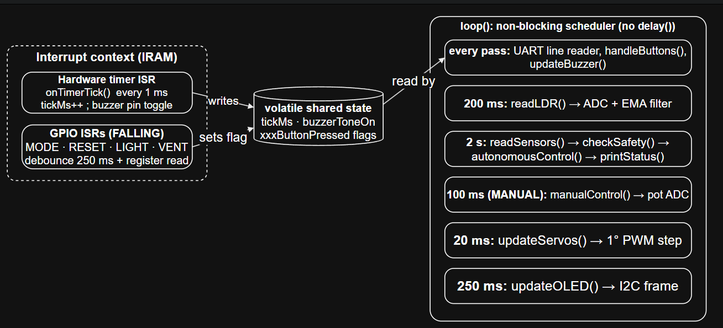

Feature implementation

Digital I/O and register-level GPIO
Outputs such as grow, amber and red LEDs, buzzer are written by “fastWrite()”, which bypasses “digitalWrite()” and sto4res a bit mark into ESP32’s GPIO pins “write-1-to-set” and “write-1-to-clear” register. The operation is therefore atomic, and it is safe inside an interrupt, where a read-modify-write could be corrupted if another pin changed at the same time. Pins 32 to 39 live in second register bank (GPIO_OUT1_....), which the function handles for the buzzer on GPIO32.
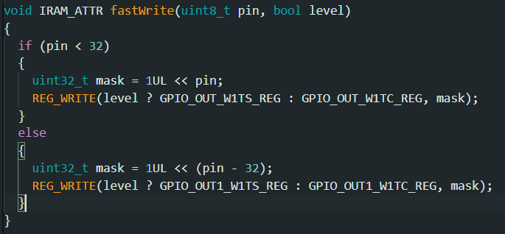
Inputs are the four buttons. The buttons are wired to ground and have internal pullups enabled. When a button is pressed a falling edge is produced. “FastRead()” reads the GPIO_IN_REG register. “FastRead()” is used inside each button ISR to confirm that the pin is low. This rejects interference spikes that might trigger an edge interrupt without a press. GPIO34–39 was avoided for buttons because they are input‑only and do not have pull‑ups.

Timers and interrupts
A general-purpose hardware timer is set up to count 1 million times per second and trigger an auto-reloading alarm every 1000 counts, which means every 1 millisecond (Espressif Systems, n.d.b). The interrupt service routine called “onTimerTick()” increases tickMs, the clock that takes the place of “millis()” in the program. It also changes the state of the buzzer pin when “buzzerToneOn” is true creating a 500 Hz wave, for the passive buzzer without using a PWM channel. The interrupt service routine is stored in IRAM with IRAM_ATTR so it can run when the flash cache is busy.
Each button has its own falling-edge interrupt. Mechanical contacts bounce for milliseconds. So, each interrupt service routine ignores any edge that happens within 250 milliseconds of the accepted edge. This timing is measured using tickMs. The ISR only sets a flag. The function “handleButtons()” then does the work in the main loop. This keeps latency low. It also avoids calling -reentrant functions, like “Serial.print” inside an ISR. The volatile keyword stops the compiler from catching these shared variables in registers. Without volatile the main loop might never see the updates made by the ISR.
loop() has no delay(). Each job checks timerMillis() against the time it last ran ( minus lastSensorRead is greater than or equal to SENSOR_INTERVAL). Unsigned subtraction stays correct when the counter wraps after about 49 days. The only delay() in the program is a 1.5‑second splash screen, in setup() which also lets the DHT22s stabilise after power‑up.

ADC: analogue input
The LDR module’s analogue output is read on GPIO34 and the potentiometer on GPIO35, both on ADC1. At 12-bit resolution the ADC returns 0–4095. “readLDR()” samples five times per second, converts the reading to a brightness percentage (inverted, because this LDR module reads high in darkness) and smooths it with an exponential moving average:
I remove ADC noise and short shadows without using a sample buffer. The processed value tells the system what to do through “”calcLightStage()”: when light is below 30 % I turn on one grow lamp. When light falls below 15 % I turn on both grow lamps. I set different on and off thresholds (30 %/40 % and 15 %/20 %) to create hysteresis bands so the lamps do not flicker when light hovers, near a threshold. I also use the raw reading for fault detection: if the value stays exactly at 0 or 4095 for two seconds I know the LDR is broken or shorted. In mode I map the potentiometer reading linearly from 0–4095 to 0–90° adding a one‑degree dead band so ADC jitter does not make the servos chase each other.

PWM servo control
Servos need a 50 Hz pulse train. The width of each pulse between 0.5 and 2.4 milliseconds controls the angle of the servo. The ESP32Servo library, written by Harrington builds this pulse using the ESP32’s LEDC PWM peripheral. Each servo has its hardware channel. This setup gives pulse timing and uses no extra CPU time. The angle is never hard‑coded. The function “decideVent()” keeps computing the desired angle from temperature, humidity, outdoor conditions and the purge timer as described in Section 2.2. The function “setVentPosition()” saves that value as a target. Then “updateServos()” moves all three servos, one degree at a time every 20 milliseconds, toward the target.

Modes of operation
The three modes are defined by a type called SystemMode. All changes of mode go through a function called changeMode(). That function prints the mode, new mode and the reason to UART. After printing it runs the entry actions, for the mode. By keeping all transitions in one function outputs stay consistent. For instance mode SAFETY always drives the vents to 30° turns the grow LEDs off and lights the red LED no matter which mode was entered from.

Scheduled and timed behaviour
Several actions are triggered by elapsed time on the hardware timer clock. The main action is the air‑exchange purge in updatePurge(). Every purge interval (120 seconds for demonstration 30 minutes in production) the vents open to at least 25 degrees, for 20 seconds breaking up stagnant air pockets even when temperature and humidity are acceptable. The OLED displays a countdown to the purge. The safety siren is also timed: ten seconds continuous, then a chirp every five seconds without being unbearable.

Serial communication (UART)
UART at 115200 baud serves two purposes. Output: printStatus prints a status block every two seconds, in every mode. The printStatus block covers readings, vent angle and reason light stage, mode and any fault. Every mode change and button press is also logged. Configuration input: checkSerialCommands assembles characters into a line without blocking. ApplySetting parses commands of the form SET <name> <value> for seven thresholds. Each threshold is range-checked. For example SET HIGH 50 is rejected because it would exceed the temperature. A line is processed on Enter or after 300 ms of silence. The terminal works even when the Serial Monitor sends no line ending.

I2C OLED display
The 128×64 SSD1306 OLED is controlled through I2C using GPIO21 for SDA and GPIO22 for SCL with the device address set to 0x3C. It uses the Adafruit library (Adafruit, n.d.) which stores the display data in a 1 KB frame buffer, in RAM. When the display is updated the entire buffer is sent in one go. At the default I2C speed of 100 kHz updating the screen takes around 90 milliseconds. To make it faster the bus speed is increased to 400 kHz, which reduces the update time to 25 milliseconds. The updateOLED() function runs every 250 milliseconds. It shows temperature, humidity, light level and vent status on all three screens as required. It also includes context like the vent reason, purge countdown or any failed sensor alerts.

Sensor validation and safety logic
evaluateSensors() checks each reading, against the DHT22s range, minus forty to eighty degrees Celsius and zero to one hundred percent relative humidity (Aosong, n.d.). If a sensor is disconnected it returns NaN. That is caught first. To avoid alarms caused by a single bad packet checkSafety() requires two consecutive bad readings. With a two-second read interval a real fault is acted upon within four seconds. That is effectively immediate compared with the minutes it takes a nursery to heat up. To recover you must press the RESET button and tryResetSafety() takes a reading before it accepts the reset.

User Manual

Components
Qty | component | purpose
1 | ESP32 | Controller
2 | DHT22 temperature & humidity sensor | Indoor (primary) and outdoor air
1 | LDR module with analogue output | Natural light level
1 | 10 kΩ potentiometer | Manual vent angle
4 | Red, orange, white, blue | Grow lamps, MANUAL and FAULT indicators
1 | Passive piezo buzzer | Alarm
4 | Tactile push-buttons | MODE, RESET, LIGHT, VENT
1 | SSD1306 0.96" 128×64 I2C OLED | Status display
1 | 5 V supply (≥1 A) or USB, breadboard and jumper wires | Power and wiring

Wiring
Wire the system as shown in Figure 5 and Table 6. Every button connects between its GPIO and GND; no resistor is needed because the internal pull-ups are enabled. Each LED’s anode goes to its GPIO and its cathode to GND through a 220 Ω resistor. Power the servos from 5 V (VIN or an external supply) with a common ground. Three servos can draw more current than a USB port supplies, which causes brown-out resets.
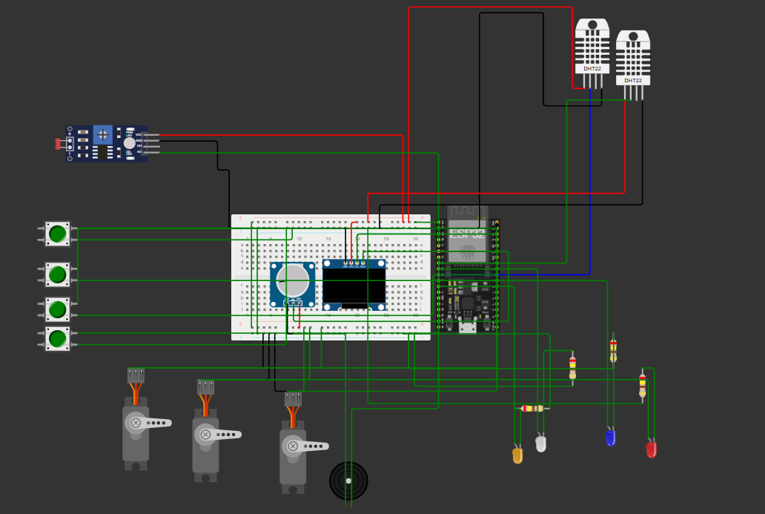

GPIO | Connected to | Type | GPIO | Connected to | Type
26 | DHT22 indoor DATA | Digital in | 18 | Servo 1 signal | PWM out
33 | DHT22 outdoor DATA | Digital in | 19 | Servo 2 signal | PWM out
34 | LDR AO | ADC1 in | 23 | Servo 3 signal | PWM out
35 | Potentiometer wiper | ADC1 in | 25/27 | Grow LED 1 / 2 | Digital out
4 | MODE button | Interrupt in | 14 | Manual LED (amber) | Digital out
13 | RESET button | Interrupt in | 16 | Fault LED (red) | Digital out
17 | LIGHT button | Interrupt in | 32 | Buzzer + | Timer-driven out
5 | VENT button | Interrupt in | 21/22 | OLED SDA / SCL | I2C

Software set-up
1.Install the Arduino IDE and the " by Espressif Systems" board package. Choose ESP32 Dev Module.
2.Install the libraries: Adafruit SSD1306, Adafruit GFX, DHT sensor library, Adafruit Unified Sensor and ESP32Servo.
3.Nursery.ino. If your LDR shows values in darkness set LDR_HIGH_MEANS_DARK to false. If there is no sensor connected set HAS_OUTDOOR_SENSOR to 0.
4.Upload the code then open the Serial Monitor at 115200 baud. The start-up banner, configuration and help text show up.
5.Simulation alternative: open the Wokwi link, on the title page. It uses the diagram.json and libraries.txt. Press Run.

Operating each mode

Autonomous
There is no need to do anything. The vents act based on temperature, humidity and the purge schedule. The grow lamps adjust to the level: one lamp when it is dim and two lamps when it is dark. The OLED displays the readings show the vent angle and explains why the vents are, at that angle and tells you how much time remains until the purge.

Manual Override (maintenance / sanitation)
1.Press MODE. The amber LED turns on the OLED display shows an inverted "MANUAL OVERRIDE / AUTOMATION SUSPENDED" message and the vents stay completely open.
2.Press VENT to go from OPEN to LOCKED CLOSED to POT. In POT, adjust the potentiometer to choose any angle.
3.Press LIGHT to turn the grow lights on or off.
4.Press MODE more to go back to Autonomous. The automation starts again away.

Safety (sensor fault)
1. If a sensor fails with the red LED lights the siren sounds the vents move to 30°. The grow lamps switch off. The flashing OLED shows the name of the failed sensor and the reason for the failure.
2. Inspect the wiring of the named sensor. Reconnect or replace it.
3. Wait for at least two seconds then press RESET. If the sensor is still faulty the reset will be refused (the event will be logged onto the port) and the alarm will continue; otherwise, the system will return to Autonomous.

Configuration (engineers)
Type a command in the Serial Monitor and press Enter. Out-of-range values are rejected, and settings return to their defaults after a power cycle.
Command | Default | Allowed | Effect
SET HIGH <°C> | 30 | MIN < x < CRIT | Heat venting starts
SET CRIT <°C> | 35 | HIGH < x ≤ 60 | Critical heat: vents fully open, lamps off
SET MIN <°C> | 18 | 0 ≤ x < HIGH | Below this the vents stay closed
SET COLD <°C> | 10 | −20 to 25 | Outdoor "dangerously cold" limit
SET HUM <%> | 85 | 50 to 99 | Humidity venting starts
SET PURGE <s> | 120 | 30 to 7200 | Interval between air purges
SET OUT <°C> | 15 | any | Simulated outdoor temperature (no outdoor sensor)

Symptom | Likely cause | Remedy
Grow LEDs on in bright light | LDR module reads the other way | Set LDR_HIGH_MEANS_DARK = false
"LDR SENSOR" fault in very bright light | ADC reads exactly 0 at full sun | Set CHECK_LDR_FAULT = false or shade the LDR
ESP32 resets when vents move | Servos powered from USB | Use an external 5 V supply, common GND
OLED blank | Wrong address or SDA/SCL swapped | Check wiring; try address 0x3D
RESET refused after reconnecting | DHT22 needs 2 s between reads | Wait 2 s and press RESET again

Commercial IoT Appraisal
Two commercial controllers that share the goal of automatically maintaining a crop’s climate within set limits were compared to the prototype.Priva Compass (Priva, n.d.a; n.d.b) is a climate computer designed for small and medium greenhouses.Priva Compass uses a Priva Blue ID C4 controller that has I/O modules and is housed in an IP55 enclosure. Separate 24 V DC power supplies are provided for the controller and the field devices.Priva Compass records data in a gateway and uploads it to the cloud to allow remote operation.Priva Compass supports a weather station. Can manage four vents, six cooling stages, four heating stages, as well as screens, lighting, CO₂ and irrigation.Priva Compass uses separate lee‑side vents and wind‑side vents.The wind‑side vent follows the lee‑side vent using a "lagging" setting that growers can increase as wind speed rises (Priva, n.d.c). Thus the opening of vents is conditioned on weather.Autogrow/Bluelab IntelliClimate (Bluelab, n.d.b) is aimed at growing rooms.
Autogrow/Bluelab IntelliClimate’s EnviroSensor measures temperature with an accuracy of plus or minus 0.5 °C, humidity with plus or minus 2 percent, light and CO₂. An optional outside‑temperature sensor is available. Autogrow/Bluelab IntelliClimate controls fans, heaters, coolers, two light banks, dehumidifiers and CO₂ through relay boxes that are sold separately. Autogrow/Bluelab IntelliClimate’s documented fail‑safes focus on equipment. Autogrow/Bluelab IntelliClimate forces fans to run if the air‑conditioner or dehumidifier fails, switches, to the light bank if a lamp fails turns lighting off if lamp shades overheat and sequences lights after a power failure (Bluelab, n.d.a). Autogrow/Bluelab IntelliClimate remote access is provided via the IntelliGrow cloud subscription. A retail kit costs US$1,500 to US$1,700 (BetterGrow Hydro, n.d.).

Aspect | Priva compass | InteliClimate | This prototype
Sensing | Zone climate boxes + weather station (outdoor) | T, RH, light, CO₂; optional outdoor T | Indoor T/RH, outdoor T, light
Vent / cooling | 4 vents, lee/wind logic, wind-dependent lagging | Fans / coolers via relays (on/off) | 1 vent group (3 servos), proportional 0–90°
Outdoor-aware logic | Yes: wind speed conditions opening | Outdoor T input available | Yes: severity-weighted cold cap
Fail-safe | Alarm page with location and time | Equipment-failure fallbacks | Sensor-failure safe posture + degraded mode
Operator interface | Touch/remote dashboard, graphs | Controller + cloud app | OLED, 4 buttons, UART
Connectivity / data | Gateway, cloud history, 5-controller network | Subscription cloud | None (Won’t Have)
Build quality | IP55 industrial, 24 V DC isolation | Commercial enclosure | Breadboard prototype

The comparison confirms the prototype’s design decision: both products see outdoor conditions as something that affects ventilation. Priva’s system slows down when wind is low which is similar in idea to the prototype’s cap a limit on how much the vent can open that loosens as the indoor need increases. The prototype’s clear approach to sensor failure is an advantage. The IntelliClimate documentation talks about plans if equipment stops working but the public version does not say what happens when a sensor fails. Also, the prototype uses a servo vent, which gives finer control while IntelliClimate relies on simple on/, off switches.
The gaps are equally clear. I see that commercial systems are networked commercial systems log history. Raise remote alarms whereas prototype fault is only visible to someone standing beside prototype fault. Commercial systems also use enclosures and isolated 24 V supplies they measure wind and CO₂ and they manage heating so commercial systems can actively correct cold rather than merely avoid making it worse. The next valuable steps would therefore be MQTT alarms, over Wi-Fi, persistent configuration and a relay-driven heater stage.

Testing

Testing covered all three modes, every transition, the priority logic, the safety logic and edge cases. To ensure that results are repeatable and not anecdotal the unmodified nursery.ino was compiled into a test harness that replaces the hardware with simulated equivalents: GPIO registers, ADC, DHT22s, servos, OLED and UART. The harness fires the timer interrupt, per simulated millisecond applies inputs and reads the outputs, which include servo angles, register bits, OLED text and serial log. The firmware was also compiled for the ESP32 target with all warnings enabled and no warnings appeared. Table 10 records the results; all 38 tests pass.

ID | Area | Test case | Expected result | Actual result | Pass/fail
T01 | Start-up | Boot: starts in AUTONOMOUS, OLED + serial banner | Enters AUTONOMOUS; OLED "AUTO MODE"; start-up banner on serial | mode=AUTONOMOUS, OLED header 'AUTO MODE', serial banner printed | PASS
T02 | Start-up | Hardware timer: 1000 ISR ticks = 1000 ms | 1000 timer interrupts advance the clock by exactly 1000 ms | tickMs advanced 1000 for 1000 ISR calls | PASS
T03 | Start-up | Normal climate (25C/60%, out 20C, bright): vents closed, LEDs off | Vents 0°; both grow LEDs off | vent=0° [CLOSED], LED1=0 LED2=0 | PASS
T04 | Auto: lights | Dim light (25%): stage 1, LED1 only | LED1 on, LED2 off | light=25%, LED1=1 LED2=0 | PASS
T05 | Auto: lights | Dark (10%): stage 2, LED1 + LED2 | LED1 and LED2 on; OLED shows "LEDs:1+2" | light=10%, LED1=1 LED2=1, OLED 'LEDs:1+2' | PASS
T06 | Auto: lights (edge) | Light hysteresis 18%->25%->35%->45% | Stage 2 → 1 → 1 (dead band) → 0, no flicker | stage 2 -> 1 -> 1 (dead band) -> 0 | PASS
T07 | Auto: heat | Heat 32C, outdoor 20C: proportional opening | Vent 48° "HEAT" (20 + 0.4×70) | vent=48° [HEAT] (calc 20+0.4x70=48) | PASS
T08 | Auto: heat (edge) | Heat hysteresis: 29.5C keeps venting, 28.9C closes | 29.5 °C holds 20°; 28.9 °C closes to 0° | 29.5C -> 20°, 28.9C -> 0° | PASS
T09 | Auto: heat | Critical heat 36C: fully open, grow LEDs forced off, alert | Vent 90°; grow LEDs off even though dark; alert on OLED + serial | vent=90 [CRIT HEAT], LED1=0 LED2=0 (dark), buzzer+OLED alert | PASS
T10 | Priority logic | DESIGN CHALLENGE 32C in / 5C out: cold-limited | Vent capped at 27° "COLD LIMIT" | vent=27° [COLD LIMIT] (heat asks 48, cap 15+0.16x75=27) | PASS
T11 | Priority logic | 34C in / 5C out: cap widens with heat severity | Vent 63° (cap 15 + 0.64×75) | vent=63° [COLD LIMIT] (heat asks 76, cap 63) | PASS
T12 | Priority logic | 35C in / 5C out: heat now dominates, fully open | Vent 90° (heat dominates) | vent=90° [CRIT HEAT] | PASS
T13 | Priority logic (edge) | Too cold 16C + humid 92%: stays closed | Vent 0° "TOO COLD" (overrides humidity) | vent=0° [TOO COLD] | PASS
T14 | Priority logic | Humidity 90% vents 35; 80% holds (hysteresis); 74% closes | 35° at 90 %; held at 80 %; 0° at 74 % | 90%->35, 80%->35, 74%->0° | PASS
T15 | Priority logic | Humid 90% but 5C outside: capped | Vent limited to 15° "COLD LIMIT" | vent=15° [COLD LIMIT] | PASS
T16 | Priority logic (edge) | Outside hotter (34C) than inside (32C): no heat venting | Vent 0° "OUT HOTTER" | vent=0° [OUT HOTTER] | PASS
T17 | Priority logic (edge) | Outdoor sensor lost: stays AUTO, assumes cold | Stays AUTONOMOUS; treats outdoor as cold (27°); OLED warning | mode=AUTONOMOUS, vent=27 [COLD LIMIT], OLED 'Out:SENSOR FAULT' | PASS
T18 | Scheduled | Scheduled purge: 25 deg after 120 s, closes after 20 s | Vent 25° "PURGE" after 120 s; 0° after 20 s | at 120 s vent=25 [PURGE]; after 20 s vent=0 | PASS
T19 | Manual | MODE button: MANUAL, amber LED, vents locked open, OLED | MANUAL; amber LED on; vents 90°; OLED "MANUAL OVERRIDE / AUTOMATION SUSPENDED" | mode=MANUAL OVERRIDE, amber=1, vent=90 [LOCKED OPEN] | PASS
T20 | Manual | Manual ignores automation (36C, dark) | Vents stay 90°; LEDs unchanged | vent=90, LED1=0 LED2=0 (unchanged) | PASS
T21 | Manual | VENT button cycles CLOSED -> POT -> OPEN; pot sets angle | 0° → pot control (2048→45°, 4095→90°) → locked open | closed=0, pot 2048->45, pot 4095->90, back to LOCKED OPEN | PASS
T22 | Manual | LIGHT button toggles both grow LEDs in MANUAL | Both LEDs on, then both off | press1: both ON, press2: LED1=0 LED2=0 | PASS
T23 | Manual (edge) | switch bounce (3 edges in 10 ms) = 1 press | Exactly one toggle | LEDs toggled once -> LED1=1 LED2=1 | PASS
T24 | Manual | MODE again: back to AUTONOMOUS, amber off | AUTONOMOUS; amber LED off | mode=AUTONOMOUS, amber=0 | PASS
T25 | Manual (edge) | LIGHT/VENT pressed in AUTO are ignored | Presses ignored with serial message; outputs unchanged | serial: 'Ignored - ... only works in MANUAL mode' | PASS
T26 | Safety (edge) | single NaN glitch does not trip SAFETY | Remains AUTONOMOUS | 1 bad read then good -> mode=AUTONOMOUS | PASS
T27 | Safety | Indoor DHT22 disconnected (NaN): SAFETY | SAFETY within 4 s; vents 30°; red LED on; grow LEDs off; siren | SAFETY after 3691 ms; vent=30, red LED=1, LED1=0 LED2=0, siren 300/600 ms | PASS
T28 | Safety | SAFETY OLED names failed sensor + prompts operator | OLED names failed sensor and cause; prompts RESET | OLED: '!! SENSOR FAULT !!' / 'Failed:INDOOR DHT22' / 'NO DATA (NaN)' / 'Fix sensor > RESET' | PASS
T29 | Safety (edge) | MODE button ignored in SAFETY | Remains SAFETY | mode=SAFETY | PASS
T30 | Safety (edge) | RESET while sensor still faulty is refused | Reset refused; remains SAFETY | serial 'RESET REFUSED - fault still present' | PASS
T31 | Safety | Siren 10 s, then short chirp every 5 s | Siren, then a ~150 ms chirp every 5 s | tone on 150 ms in a 5 s window after 10 s | PASS
T32 | Safety | Sensor fixed + RESET: back to AUTO, red LED off | AUTONOMOUS; red LED off; buzzer silent | mode=AUTONOMOUS, red=0, buzzer=0 | PASS
T33 | Safety (edge) | temperature 95C (out of range) -> SAFETY | SAFETY, "TEMP INVALID" | fault=TEMP INVALID | PASS
T34 | Safety (edge) | humidity 120% (out of range) -> SAFETY | SAFETY, "HUMID INVALID" | fault=HUMID INVALID | PASS
T35 | Safety (edge) | Sensor fault while in MANUAL: SAFETY overrides | SAFETY overrides MANUAL; vents 30° | mode=SAFETY, vent=30 | PASS
T36 | Safety (edge) | LDR stuck at 4095 (open/shorted): SAFETY | SAFETY; OLED "LDR SENSOR" | fault=LDR SENSOR - STUCK 0/4095 after 5600 ms | PASS
T37 | UART config (edge) | UART config: valid, out-of-range, no line ending, old key | Valid value accepted; out-of-range rejected; missing line ending tolerated; removed key rejected | HIGH 28 accepted; HIGH 50 rejected; PURGE 60 w/o newline accepted; 'A' -> Unknown | PASS
T38 | UART config | New threshold takes effect (29C >= new HIGH 28) | Vent opens at 29 °C | vent=30° [HEAT] | PASS

I noted that defects found during development and their remediation. Two defects were design faults, then coding errors, which shows the value of checking calculated behavior against worked examples rather than only checking that the code runs.
Id | Defect Found | Remediation | Verified by
R1 | Original draft firmware did not compile (stray "z/" token) | Removed; build is warning-free with -Wall | Compilation
R2 | Cold cap used the same curve as the heat request (both 20°+70s), so it never limited heat venting | Cap changed to 15°+75s², making cold protection effective until heat becomes critical | T10–T12
R3 | Grow LEDs lit in bright light in simulation (LDR polarity) | LDR_HIGH_MEANS_DARK flag, set true for this module | T04–T06
R4 | OLED refresh blocked the loop about 90 ms at 100 kHz I2C | I2C set to 400 kHz (about 25 ms) | Code review
R5 | Tests T22, T27, T35 and T36 first failed: the test pressed within the 250 ms debounce window, sampled the pulsing siren at one instant, or checked before servo travel had finished | Test timing corrected. The firmware behaved as designed, and debounce and servo slew are intentional | Re-run: 38/38

The test method has some limits. The harness shows that the logic, timing and outputs of the firmware work but it does not check the electrical behavior: sensor timing, servo torque, supply noise and button bounce on physical contacts. Each test in Table 10 should therefore be done again on the Wokwi simulation and on the prototype, for the demonstration. One real-hardware effect is already understood: the DHT library temporarily stops interrupts during each read so some timer ticks can combine, and the software clock might run 0.4 percent slow.

Conclusion
The prototype meets every Must. Should requirement. The prototype’s main contribution is a testable priority hierarchy in which protective limits always constrain comfort requests and the cold‑weather limit scales with the danger of overheating. The prototype’s main gaps against products are connectivity, persistence and active heating and these gaps form the plan, for future work.

Reference
Adafruit (n.d.) Adafruit_SSD1306: Arduino library for SSD1306 monochrome 128x64 and 128x32 OLEDs. Available at: https://github.com/adafruit/Adafruit_SSD1306 (Accessed: 24 September 2026).
Agile Business Consortium (2014) ‘Chapter 10: MoSCoW prioritisation’, in The DSDM Agile Project Framework Handbook. Available at: https://www.agilebusiness.org/dsdm-project-framework/moscow-prioritisation.html (Accessed: 24 September 2026).
Aosong Electronics (n.d.) Digital-output relative humidity & temperature sensor/module DHT22 (AM2302) datasheet. Available at: https://www.sparkfun.com/datasheets/Sensors/Temperature/DHT22.pdf (Accessed: 24 September 2026).
BetterGrow Hydro (n.d.) Autogrow IntelliClimate Kit w/EnviroSensor (Temp/RH/Light/CO2). Available at: https://www.bghydro.com/products/autogrow-intelliclimate-kit-w-envirosensor-temp-rh-light-co2 (Accessed: 24 September 2026).

